Greek City States Crossword
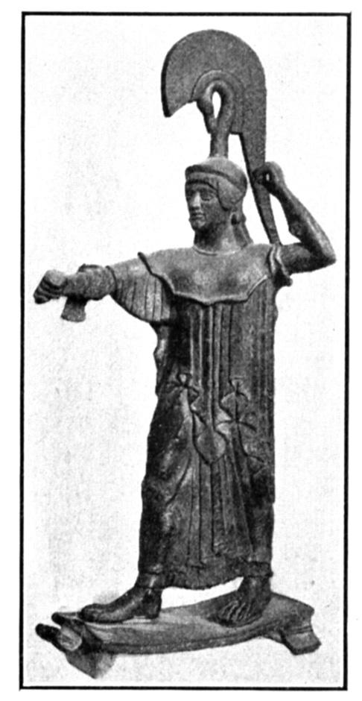
Across
4. A government that is controlled by a powerful group of citizens.
6. A person who controls a government alone, usually by force.
7. The wealthy ruling class.
9. A militaristic Greek city-state.
12. A time of great economic, intellectual, and artistic growth.
13. The Greek word for city-state.
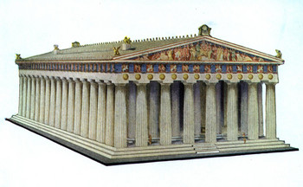
Down  1. A government where all citizens can vote.  2. A fortress on a hill.  3. Slaves owned by the city-state of Sparta.  5. A country that consists of a city plus the surrounding countryside. | 8. Greek city-state famous for democratic government.  10. A Greek marketplace.  11. A place where Greeks heard predictions about the future.

