Spanish Conquest of the Inca Civilization
The Inca Empire ended shortly after the arrival of the Spanish. What factors aided the Spanish in their conquest?
aided | civil |  | conquistadors | Cuzco
divided | hostage |  | outnumbered | Pizarro
population | smallpox |  | successor | weapons
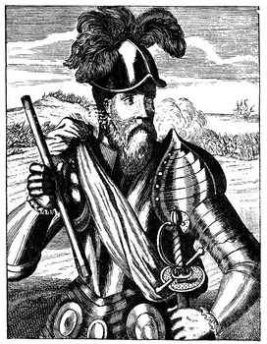  Francisco Pizarro |  | In 1532-33, a small band of 168 Spanish _________, led by Francisco _________ were able to capture the Inca emperor and the Inca capital city of _________, effectively bringing the Inca Empire to an end. How was such a small band of soldiers able to defeat an empire?
The Spanish were _________ in their conquests by several factors. Even before Pizarro's conquest began, the disease _________ had spread through the Andes devastating the Inca _________.
To make matters worse, the emperor Huayna Capac died of smallpox in 1527. His oldest son, who was the _________ to the throne, died shortly after. His remaining two sons began a _________ war for the right of succession. This war _________ the empire.
Finally, the superior _________ and daring of the Spanish conquistadors in the early stage of the conflict contributed to their success. Vastly _________, the Spaniards launched a surprise attack on the Incas who had never seen horses or cannons and captured the Inca emperor. With their emperor being held _________, the Inca army was unable to launch an attack on the much smaller Spanish force.

